Infovis Final Report

| Catarina Mendonça  75381 | Rúben Vines  **76991** |  |
| --- | --- | --- |

# INTRODUCTION

The domain of our problem is the food and beverages consumption worldwide and some health

# RELATED WORK

On each page your material should fit within a rectangle of 7 x 9.25 in (18 x 23.5 cm), centered on a US letter page (8.5x11 in), beginning 0.75 in (1.9 cm) from the top of the page, with a 0.33 in (0.85 cm) space between two 3.3 in (8.4 cm) columns. Right margins should be justified, not ragged. Please be sure your document and PDF are US letter and not A4.

# TYPESET TEXT

The styles contained in this document have been modified from the default styles to reflect ACM formatting conventions. For example, content paragraphs like this one are formatted using the Normal style.

# THE DATA

The heading of a section should be in Arial 9-point bold, all in capitals (Heading 1 style). Sections should not be numbered.

# THE VISUALIZATIOM

The heading of a section should be in Arial 9-point bold, all in capitals (Heading 1 style). Sections should not be numbered.

## Overall Description

## Rationale

## Demonstrate the Potential

Headings of subsections should be in Arial 9-point bold with initial letters capitalized (Heading 2 style). For sub-sections and sub-subsections, a word like *the* or *of* is not capitalized unless it is the first word of the heading.

# IMPLEMENTATION DETAILS

Place figures and tables at the top or bottom of the appropriate column or columns, on the same page as the relevant text (see Figure 1). A figure or table may extend across both columns to a maximum width of two columns, or 17.78 cm (7 in.).

Captions should be Times New Roman 9-point bold (Caption style). They should be numbered (e.g., “Table 1” or “Figure 2”), centered, and placed beneath the figure or table. The words “Figure” and “Table” should be spelled out (e.g., “Figure” rather than “Fig.”) wherever they occur.

All figures should also include alt text for improved accessibility. In Word, right click the figure, and select Format Picture | Layout | Alt Text). Papers and notes may use color figures, which are included in the page limit; the figures must be usable when printed in black-and-white in the proceedings.

The paper may be accompanied by a short video figure up to five minutes in length. However, the paper should stand on its own without the video figure, as the video may not be available to everyone who reads the paper.

## Inserting Images

Occasionally MS Word generates larger-than-necessary PDF files when images inserted into the document are manipulated in MS Word. To minimize this problem, use an image editing tool to resize the image at the appropriate printing resolution (usually 300 dpi), and then insert the image into Word using Insert | Picture | From File.

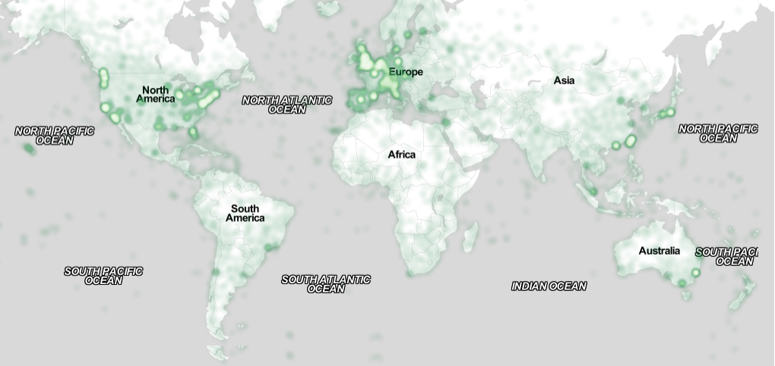

Figure . Sample of a wide figure. Be sure to place at the top or bottom of the page. Ensure that important information is legible in both black-and-white and color printing. Image: CC-BY-ND ayman on Flickr.

# Conclusion

It is important that you write for the SIGCHI audience. Please read previous years’ proceedings to understand the writing style and conventions that successful authors have used. State clearly what you have done, not merely what you plan to do, and explain how your work is different from previously published work, i.e., *the unique contribution that your work makes to the field*. Please consider what the reader will learn from your submission, and how they will find your work useful. If you write with these questions in mind, your work is more likely to be successful, both in being accepted into the conference, and in influencing the work of our field.